An integrated computational pipeline for eosinophilic esophagitis
  - Research Article
[Authors to be completed]

An integrated computational pipeline for eosinophilic esophagitis: from public omics to therapeutic targets, companion diagnostics, and a preclinical program

Abstract
Eosinophilic esophagitis (EoE) is a chronic, food-antigen-driven type-2 inflammatory disease of the esophagus with a limited therapeutic armamentarium and no approved disease-modifying therapy that durably restores esophageal homeostasis. We report an integrated, end-to-end computational pipeline that begins from the disease name and public data alone and terminates at concrete, wet-bench-ready therapeutic programs. From an inventory of 57 public datasets we harmonized 9 case-control bulk transcriptomic cohorts (235 samples: 152 EoE, 83 control) into a 567-gene meta-signature (383 up, 184 down), validated it in 166,420 esophageal single cells, and resolved the disease into reproducible endotypes and a candidate treatment-refractory molecular core (observed in the single available paired pre/post-treatment cohort, and therefore provisional). The signature recovered every canonical EoE marker with correct direction and nominated a target shortlist dominated by secreted and surface-accessible proteins. We advanced three leads to structure-grounded design specifications — SIGLEC6 (depleting antibody/ADC), IL1RL1/ST2 (blocking antibody), and CCL26/eotaxin-3 (neutralizing antibody) — each with a paired companion diagnostic that, in the derivation cohorts, addresses ≥92% of severe-endotype patients (a derivation-cohort estimate, not an independently validated one). Because EoE is a CD4/Th2 food-antigen disease, we additionally built an antigen-directed arm: MHC class II epitope maps across ten food allergens and thirteen HLA-DRB1 alleles, and a personalized food-trigger concept that we tested blind against an index patient’s clinically-established triggers — both true triggers (milk, soy) ranked in the top two of eight candidate foods (chance probability 1/28 = 0.036; a single-patient, hypothesis-generating result), while a tolerated-but-highly-presented food (wheat) exposed a general principle: antigen presentation is a prior, not a proof, of pathology. We close with a four-phase preclinical roadmap, gated on ex-vivo human T-cell validation, for the antigen-directed program. Every candidate is a hypothesis generated in silico and is presented as such; the pipeline is designed so that each output carries the evidence and the caveats needed to prioritize it for laboratory validation.

Introduction
EoE affects roughly 1 in 2,000 individuals and is rising in incidence. Its pathology is a type-2 immune response to dietary (and aeroallergen) antigens, with eosinophil and mast-cell recruitment driven by IL-5 and IL-13, a dominant interferon and NF-κB inflammatory program, and progressive loss of the epithelial barrier and terminal keratinization program^{1,2,3}. The causal role of food antigen is established by the efficacy of empirical elimination diets and by the return of inflammation on re-introduction⁴. Yet the therapeutic options remain narrow: swallowed topical corticosteroids, proton-pump inhibitors, dietary elimination, and the anti-IL-4Rα antibody dupilumab⁵ — now FDA-approved for EoE in adults and children (≥1 year), and the first approved disease-modifying biologic. Dupilumab is effective but blocks type-2 signaling broadly rather than selectively, and it does not deplete the esophageal mast-cell compartment that expands most dramatically in disease. The gap we target is therefore not a lack of any therapy but the absence of agents directed at specific disease drivers — foremost the expanded mast compartment — and of a strategy aimed at the causal food-antigen-specific T cells.
Two gaps motivate this work. First, target discovery in EoE has largely proceeded one gene at a time; a systematic, multi-cohort view of what is dysregulated, where it sits in the cell landscape, and whether it is druggable has been missing. Second, the field’s mechanistic center of gravity — a CD4/Th2 response to specific food antigens — has not been connected to a concrete, testable therapeutic modality that acts on the antigen-specific T cells themselves.
Here we address both with a single computational pipeline (Fig. 1) that runs from public omics through target nomination, structure-grounded therapeutic design, paired companion diagnostics, an antigen-directed pMHC arm, and a preclinical wet-bench program. The pipeline was executed under human supervision at each stage — for biological plausibility, prior art, and ethics — and is reported with its uncertainties intact. We intend it as the scientific foundation for a focused EoE therapeutics effort, and as a template for disease-to-design campaigns on public data.
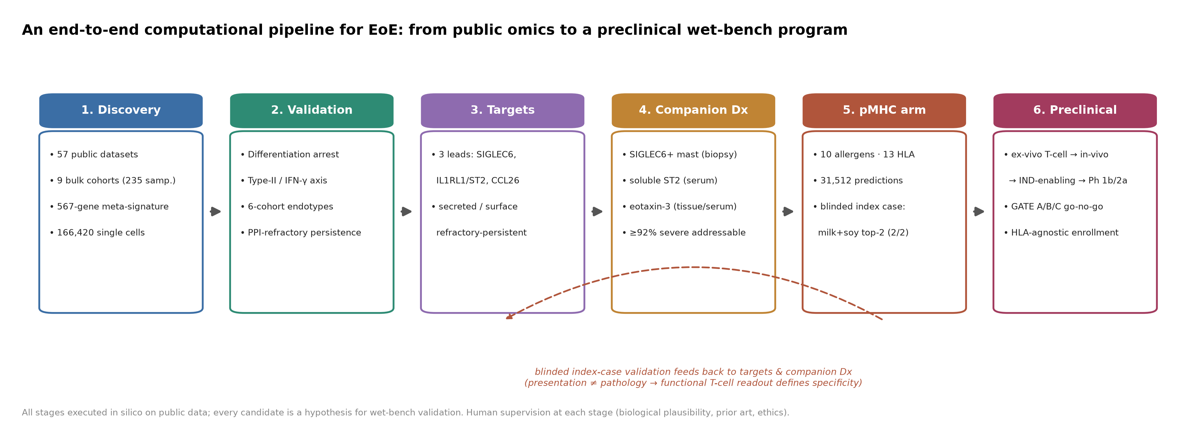
Figure 1. End-to-end computational pipeline for EoE. Six stages from public-omics discovery through validation, target selection, companion diagnostics, the antigen-directed pMHC arm, and a preclinical wet-bench program. The blinded index-case analysis feeds back to target and diagnostic selection, encoding the lesson that antigen presentation does not by itself establish pathology. All stages were executed in silico on public data under human supervision; every candidate is a hypothesis for wet-bench validation.

Results

A 567-gene meta-signature recovers EoE biology and nominates accessible targets
We inventoried 57 public EoE datasets and harmonized 9 case-control bulk transcriptomic cohorts (235 samples: 152 EoE, 83 control) to a common gene space. Differential expression pooled across cohorts yielded a high-confidence 567-gene meta-signature (383 up-regulated, 184 down-regulated; Fig. 2a). The signature recovered every canonical EoE marker with the correct direction — the eosinophil chemoattractant CCL26/eotaxin-3 as the most disease-specific up-regulated transcript (pooled log₂ fold-change 4.56, up in 9/9 cohorts, adjusted P = 3.4×10⁻⁴), alongside POSTN, ALOX15, CDH26, TPSAB1, CPA3 and the barrier genes DSG1, SPINK7 and FLG down-regulated^{2,6}. Pathway enrichment resolved a dominant interferon-γ program (q = 1.0×10⁻²⁸) and cytokine signaling superimposed on loss of keratinization and cornified-envelope assembly (q = 3.8×10⁻⁹; Fig. 2b).
We stress-tested the signature’s robustness before calling it high-confidence. Of the 567 genes, the 399 detected in at least seven of the nine cohorts — the coverage needed for a stable leave-one-cohort-out test — all survived it (each remained differentially expressed with any single cohort dropped; 399/399 classified robust-core), and every canonical marker retained a consistent direction across cohorts. The 168 genes not formally LOCO-tested were those measured in fewer than seven cohorts (typically platform- or annotation-specific); they remain in the signature on direction-consistent evidence but carry weaker cross-cohort support, and we flag them as the lower-confidence tail rather than excluding them. Between-cohort heterogeneity in effect magnitude was nonetheless substantial for several headline genes (I² = 97.6% for CCL26 and ALOX15, 96.4% for DSG1, 71.8% for POSTN, 72.9% for IL1RL1, 36.6% for SIGLEC6) — expected given platform and cohort diversity, and the reason we rely on direction-consistent, leave-one-out-robust membership rather than on pooled effect sizes alone.
Annotating the up-regulated, druggable fraction for therapeutic accessibility, 91 of 120 genes (76%) were secreted or cell-surface — the two modalities most tractable for biologics (Fig. 2c). The shortlist was therefore dominated by proteins reachable with antibodies or receptor-directed agents rather than intracellular targets.
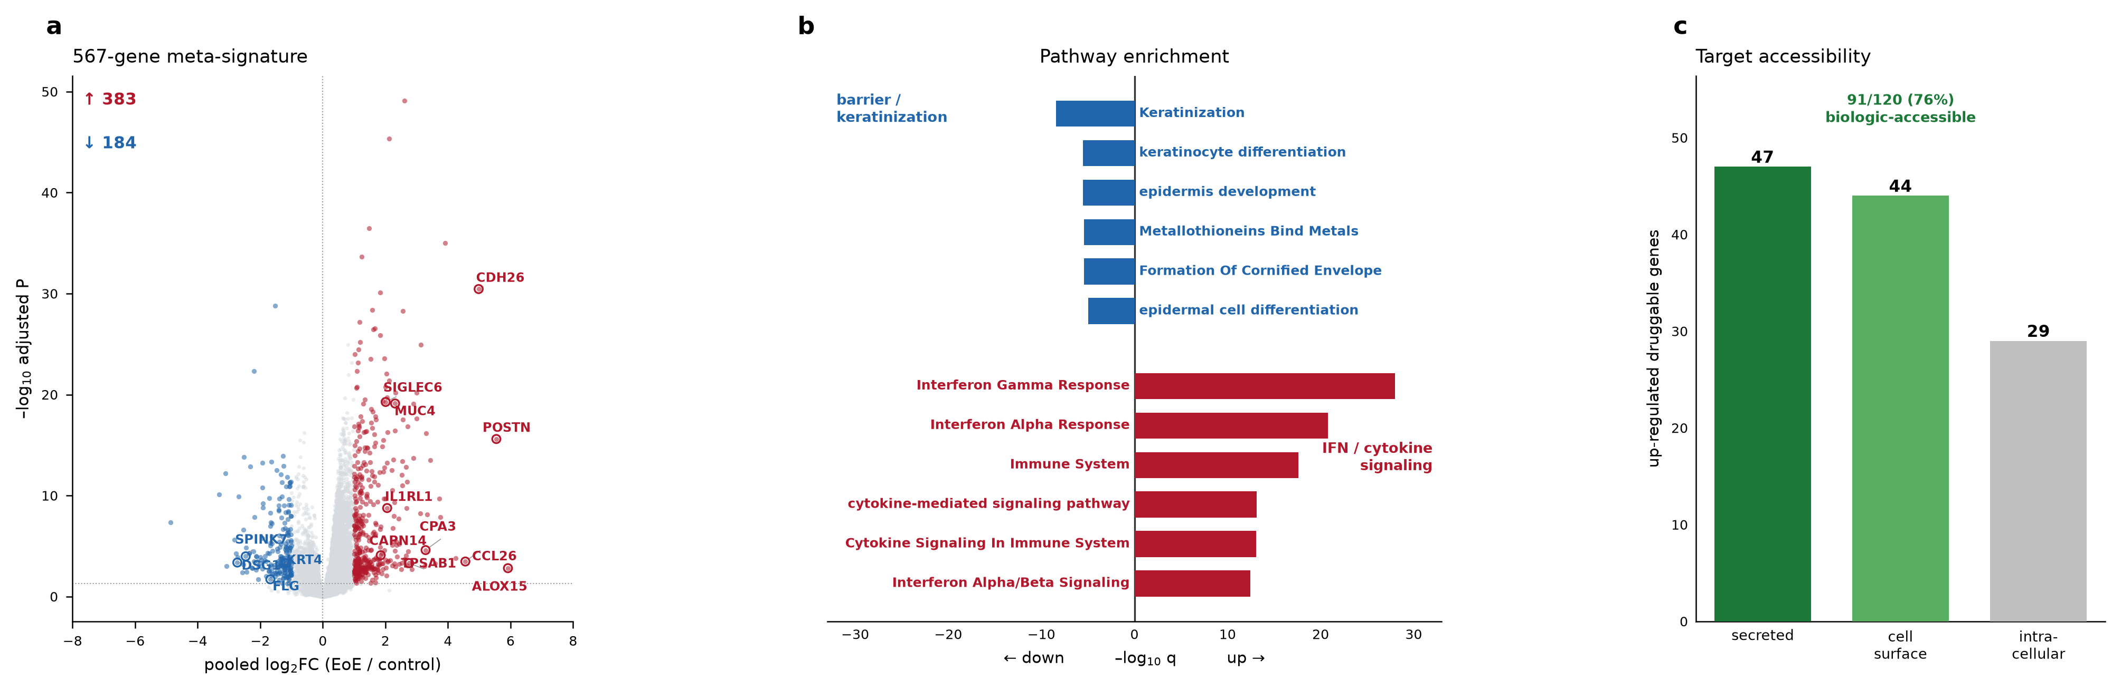
Figure 2. Discovery: a 567-gene meta-signature. (a) Volcano of the pooled signature; canonical markers labeled with correct direction. (b) Diverging pathway enrichment — up-regulated interferon and cytokine programs versus down-regulated keratinization/barrier programs. (c) Target accessibility among up-regulated druggable genes: 91 of 120 (76%) are secreted or surface-accessible.

Single-cell analysis localizes the signature to an expanded mast-cell compartment
To resolve the cellular source of the signature, we analyzed a published single-cell dataset of 166,420 esophageal cells (73,175 EoE, 93,245 healthy; Fig. 3a). The most striking compositional change was a 14-fold expansion of the mast-cell compartment, from a mean 0.19% of cells in healthy tissue to 2.63% in EoE (Mann–Whitney P = 7.2×10⁻⁵; Fig. 3b,d), accompanied by relative depletion of basal epithelium (42.7% → 30.6%)⁷. The mast compartment did not merely expand: healthy tissue was dominated by a single resting state, whereas EoE tissue diversified into multiple activated mast states (Fig. 3c). This localization directed target selection toward the mast and epithelial compartments that dominate the disease.
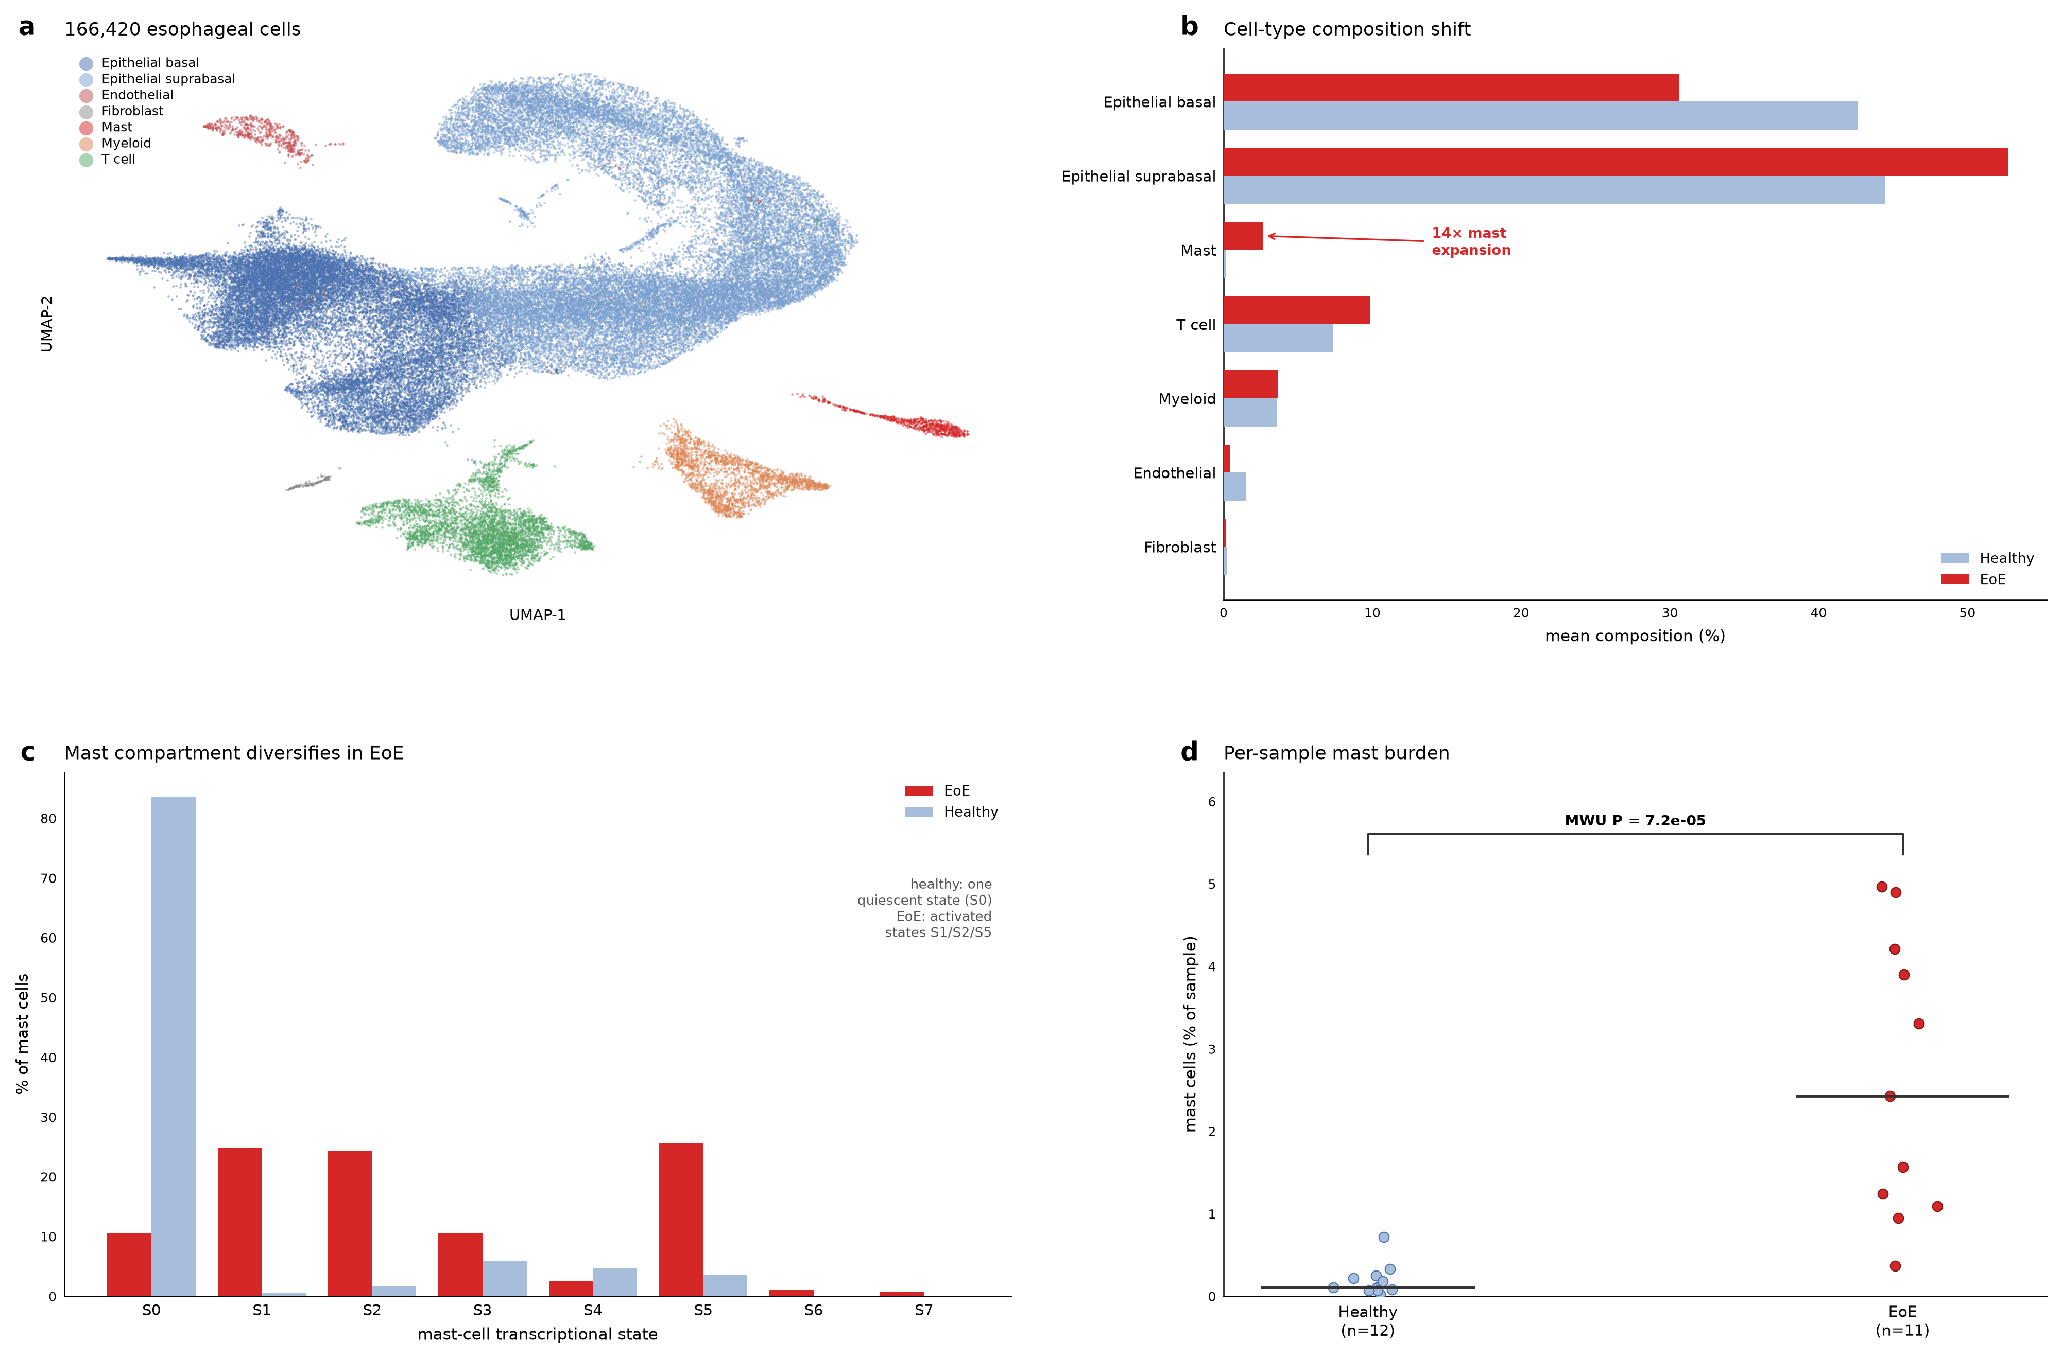
Figure 3. Single-cell landscape. (a) UMAP of 166,420 esophageal cells by cell type. (b) Compositional shift, highlighting the 14-fold mast-cell expansion. (c) Mast-state diversification in EoE. (d) Per-sample mast burden (Mann–Whitney P = 7.2×10⁻⁵).

The disease resolves into reproducible endotypes over a treatment-refractory core
Across six cohorts the disease resolved into three reproducible endotypes spanning a barrier-high/low-inflammation state to inflamed states, tracking clinical severity (Fig. 4b). Pseudotime analysis of the epithelial compartment showed a differentiation arrest: healthy epithelium populated the full terminal-differentiation trajectory, whereas EoE epithelium was truncated short of the terminal states, with the marker-based terminal-differentiation fraction falling from 17.9% in healthy tissue to 5.4% in EoE (Fig. 4a)⁶. Seven of the signature genes carry reported EoE GWAS risk variants (including CAPN14, odds ratio 1.77; DSG1, 2.22; Fig. 4c). We present this strictly as per-gene genetic annotation, not as any form of enrichment: with only seven genes and no fixed, pre-specified GWAS candidate-gene universe screened against a matched background, neither a signature-level enrichment nor a within-signature distributional claim is statistically supportable, and we make neither. We note only that the individual genes carrying reported risk variants happen to be epithelial-barrier genes (CAPN14, DSG1); we do not claim this pattern is more than would be expected by chance, and Figure 4c should be read as annotating seven individual genes rather than as testing where risk concentrates. Critically, in the only cohort with paired pre/post-treatment sampling, nine of the ten prioritized targets — every one with paired-cohort coverage (MSLN lacked data) — normalized in treatment responders but persisted in non-responders, a treatment-refractory molecular core (Fig. 4d). Because this observation rested on a single paired pre/post-treatment cohort (GSE303169), we carried it forward as a hypothesis rather than an established result; it requires replication in an independent paired cohort.
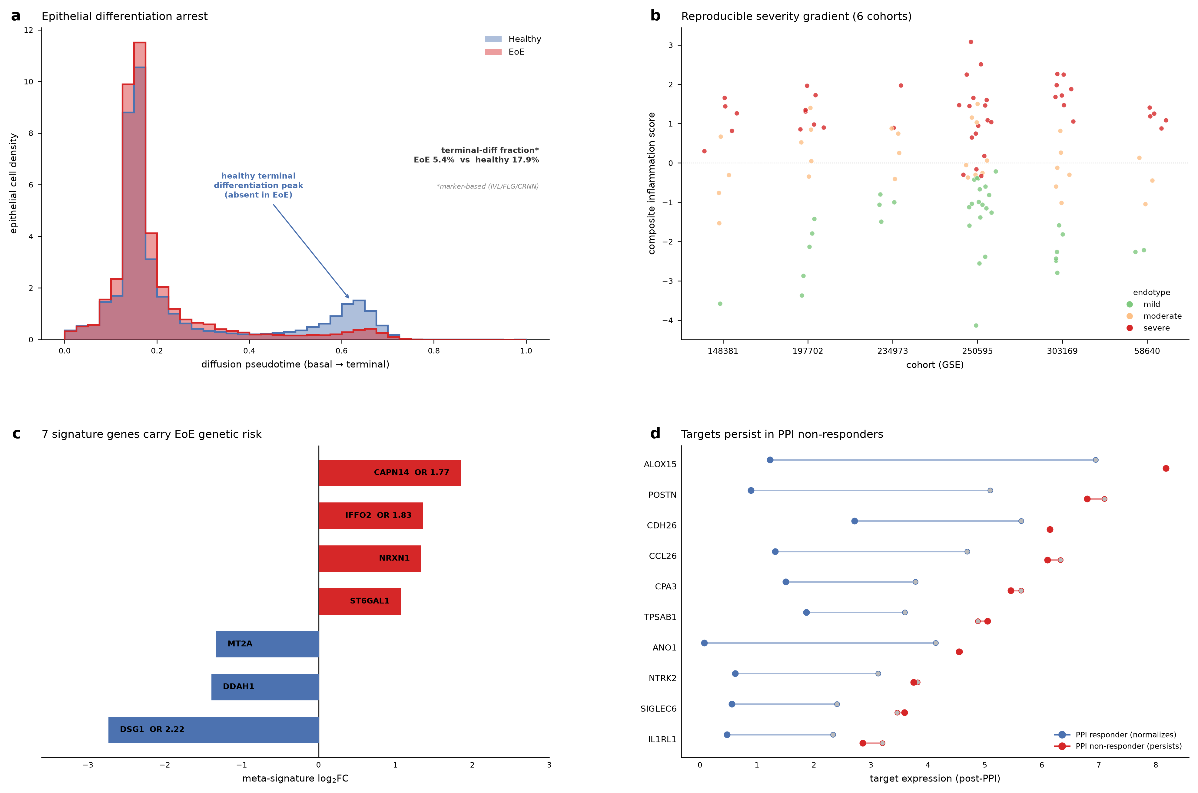
Figure 4. Validation. (a) Epithelial differentiation arrest along pseudotime; the healthy terminal-differentiation peak is absent in EoE. (b) Three endotypes across six cohorts, colored by severity. (c) Signature genes overlapping GWAS risk loci, with odds ratios. (d) PPI-refractory persistence: prioritized targets normalize in responders, persist in non-responders.

Three targets advance to structure-grounded design specifications
Integrating fold-change, cell-landscape localization, druggability, refractory persistence, and addressable patient fraction, we prioritized ten Tier-A targets (Table 1) and advanced three to full design specifications (Fig. 5, Table 2):
- SIGLEC6 — a mast-cell-restricted inhibitory receptor marking the disease-associated mast state in 8/8 bulk cohorts. Modality: depleting antibody or antibody–drug conjugate (afucosylated IgG1 for enhanced ADCC, or an MMAE/PBD payload); epitope on the membrane-distal Ig-V domain (residues 28–123); target affinity <5 nM; the rationale is that no existing EoE therapy depletes the expanded mast compartment. A tissue-selectivity caveat applies: SIGLEC6 is not exclusive to esophageal mast cells — it is also expressed on basophils and mast-cell pools in other tissues — so a depleting agent carries a systemic off-target mast/basophil-depletion risk. This is assessable in silico against public expression atlases and must be quantified before any depleting modality is advanced; a non-depleting (blocking or ADC-with-restricted-payload) design may be preferable if selectivity is insufficient.
- IL1RL1/ST2 — the IL-33 receptor, an alarmin sensor upstream of the type-2 response. Modality: blocking antibody (astegolimab/itepekimab-class) or soluble decoy; epitope across the IL-33 binding interface (Ig1–2 domains, ~1,781 Å² interface).
- CCL26/eotaxin-3 — the most disease-specific transcript, the eosinophil chemoattractant. Modality: neutralizing anti-CCL26 antibody, or an anti-CCR3 receptor agent; epitope on the mature chemokine (residues 24–94, CCR3-binding N-terminus and 40s loop). One escape-risk residue in the N-loop argues for co-engaging the rigid 40s loop or favoring the receptor route.
Per-residue ESM conservation over each backbone confirmed that the proposed epitopes sit on conserved, structurally-defined surfaces (Fig. 5).
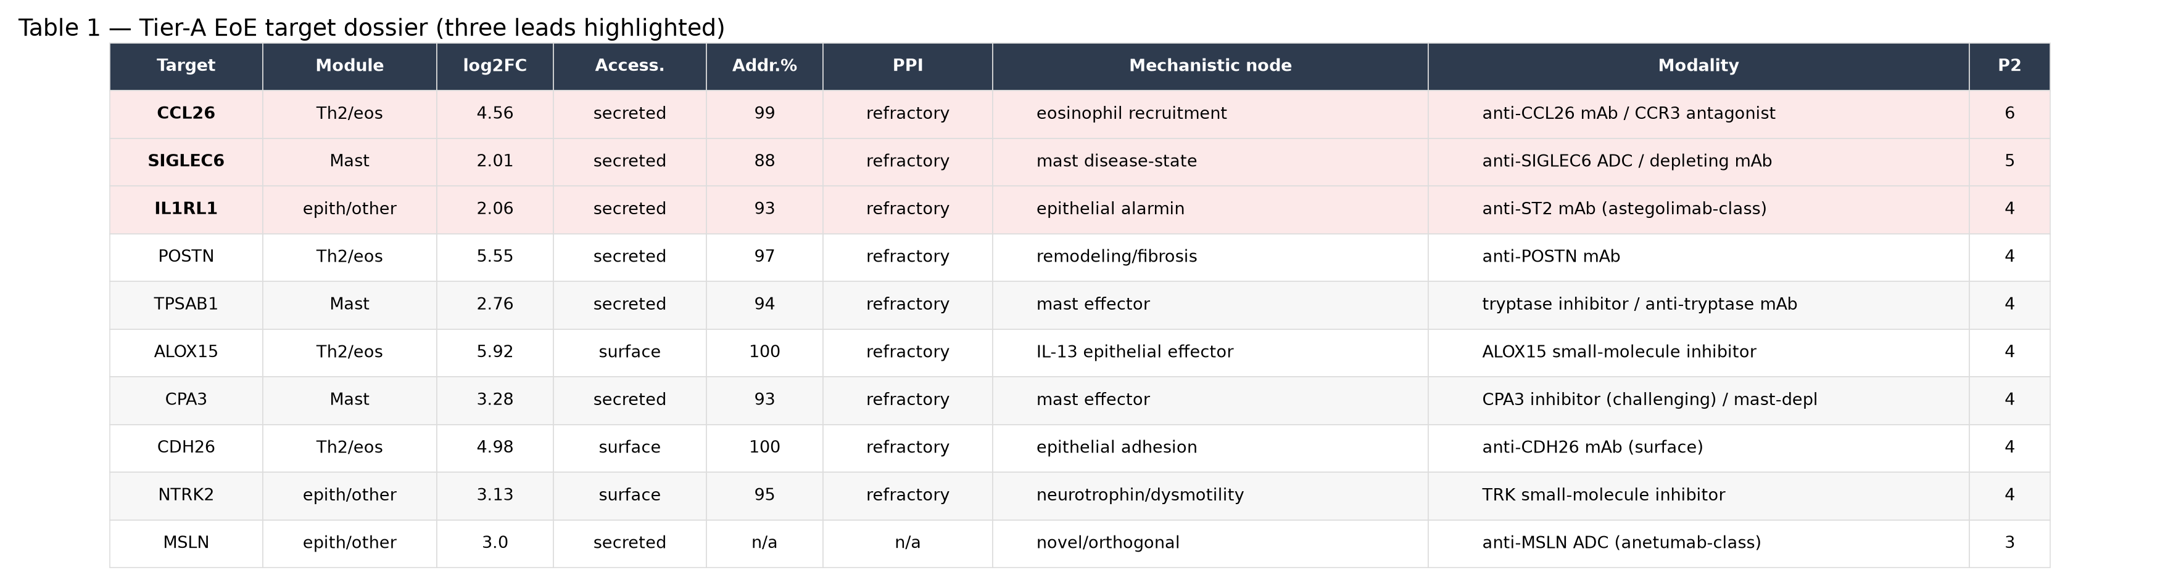
Table 1. Tier-A target dossier. Ten prioritized targets with module, pooled fold-change, accessibility, addressable fraction, refractory-persistence class, mechanistic node, modality, and prioritization score. The three leads are highlighted.
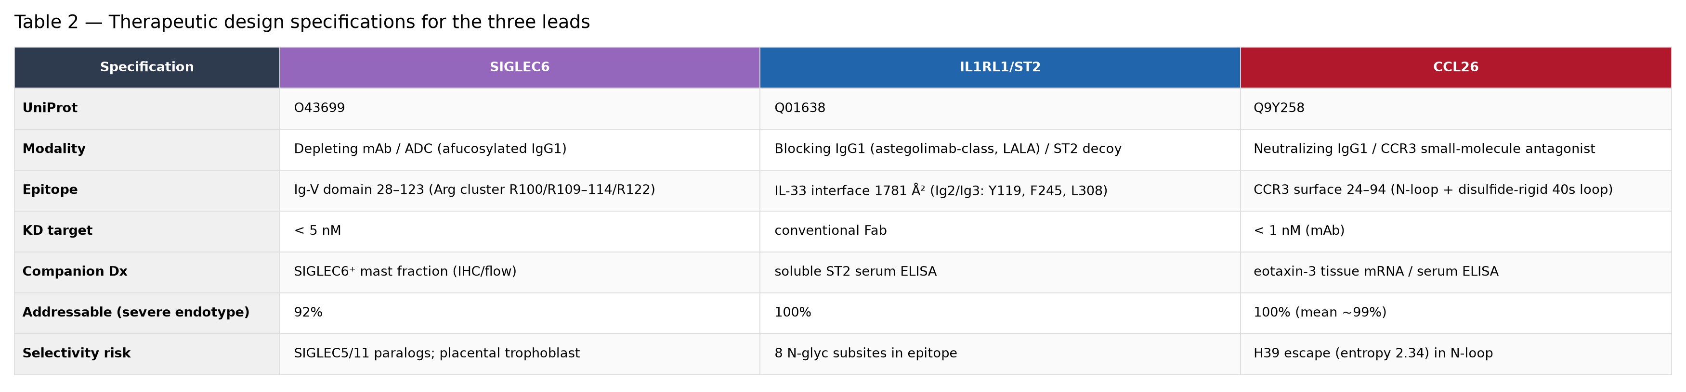
Table 2. Three-lead design specifications. UniProt accession, modality, epitope, target affinity, companion diagnostic, addressable fraction, and selectivity risk for SIGLEC6, IL1RL1/ST2 and CCL26.
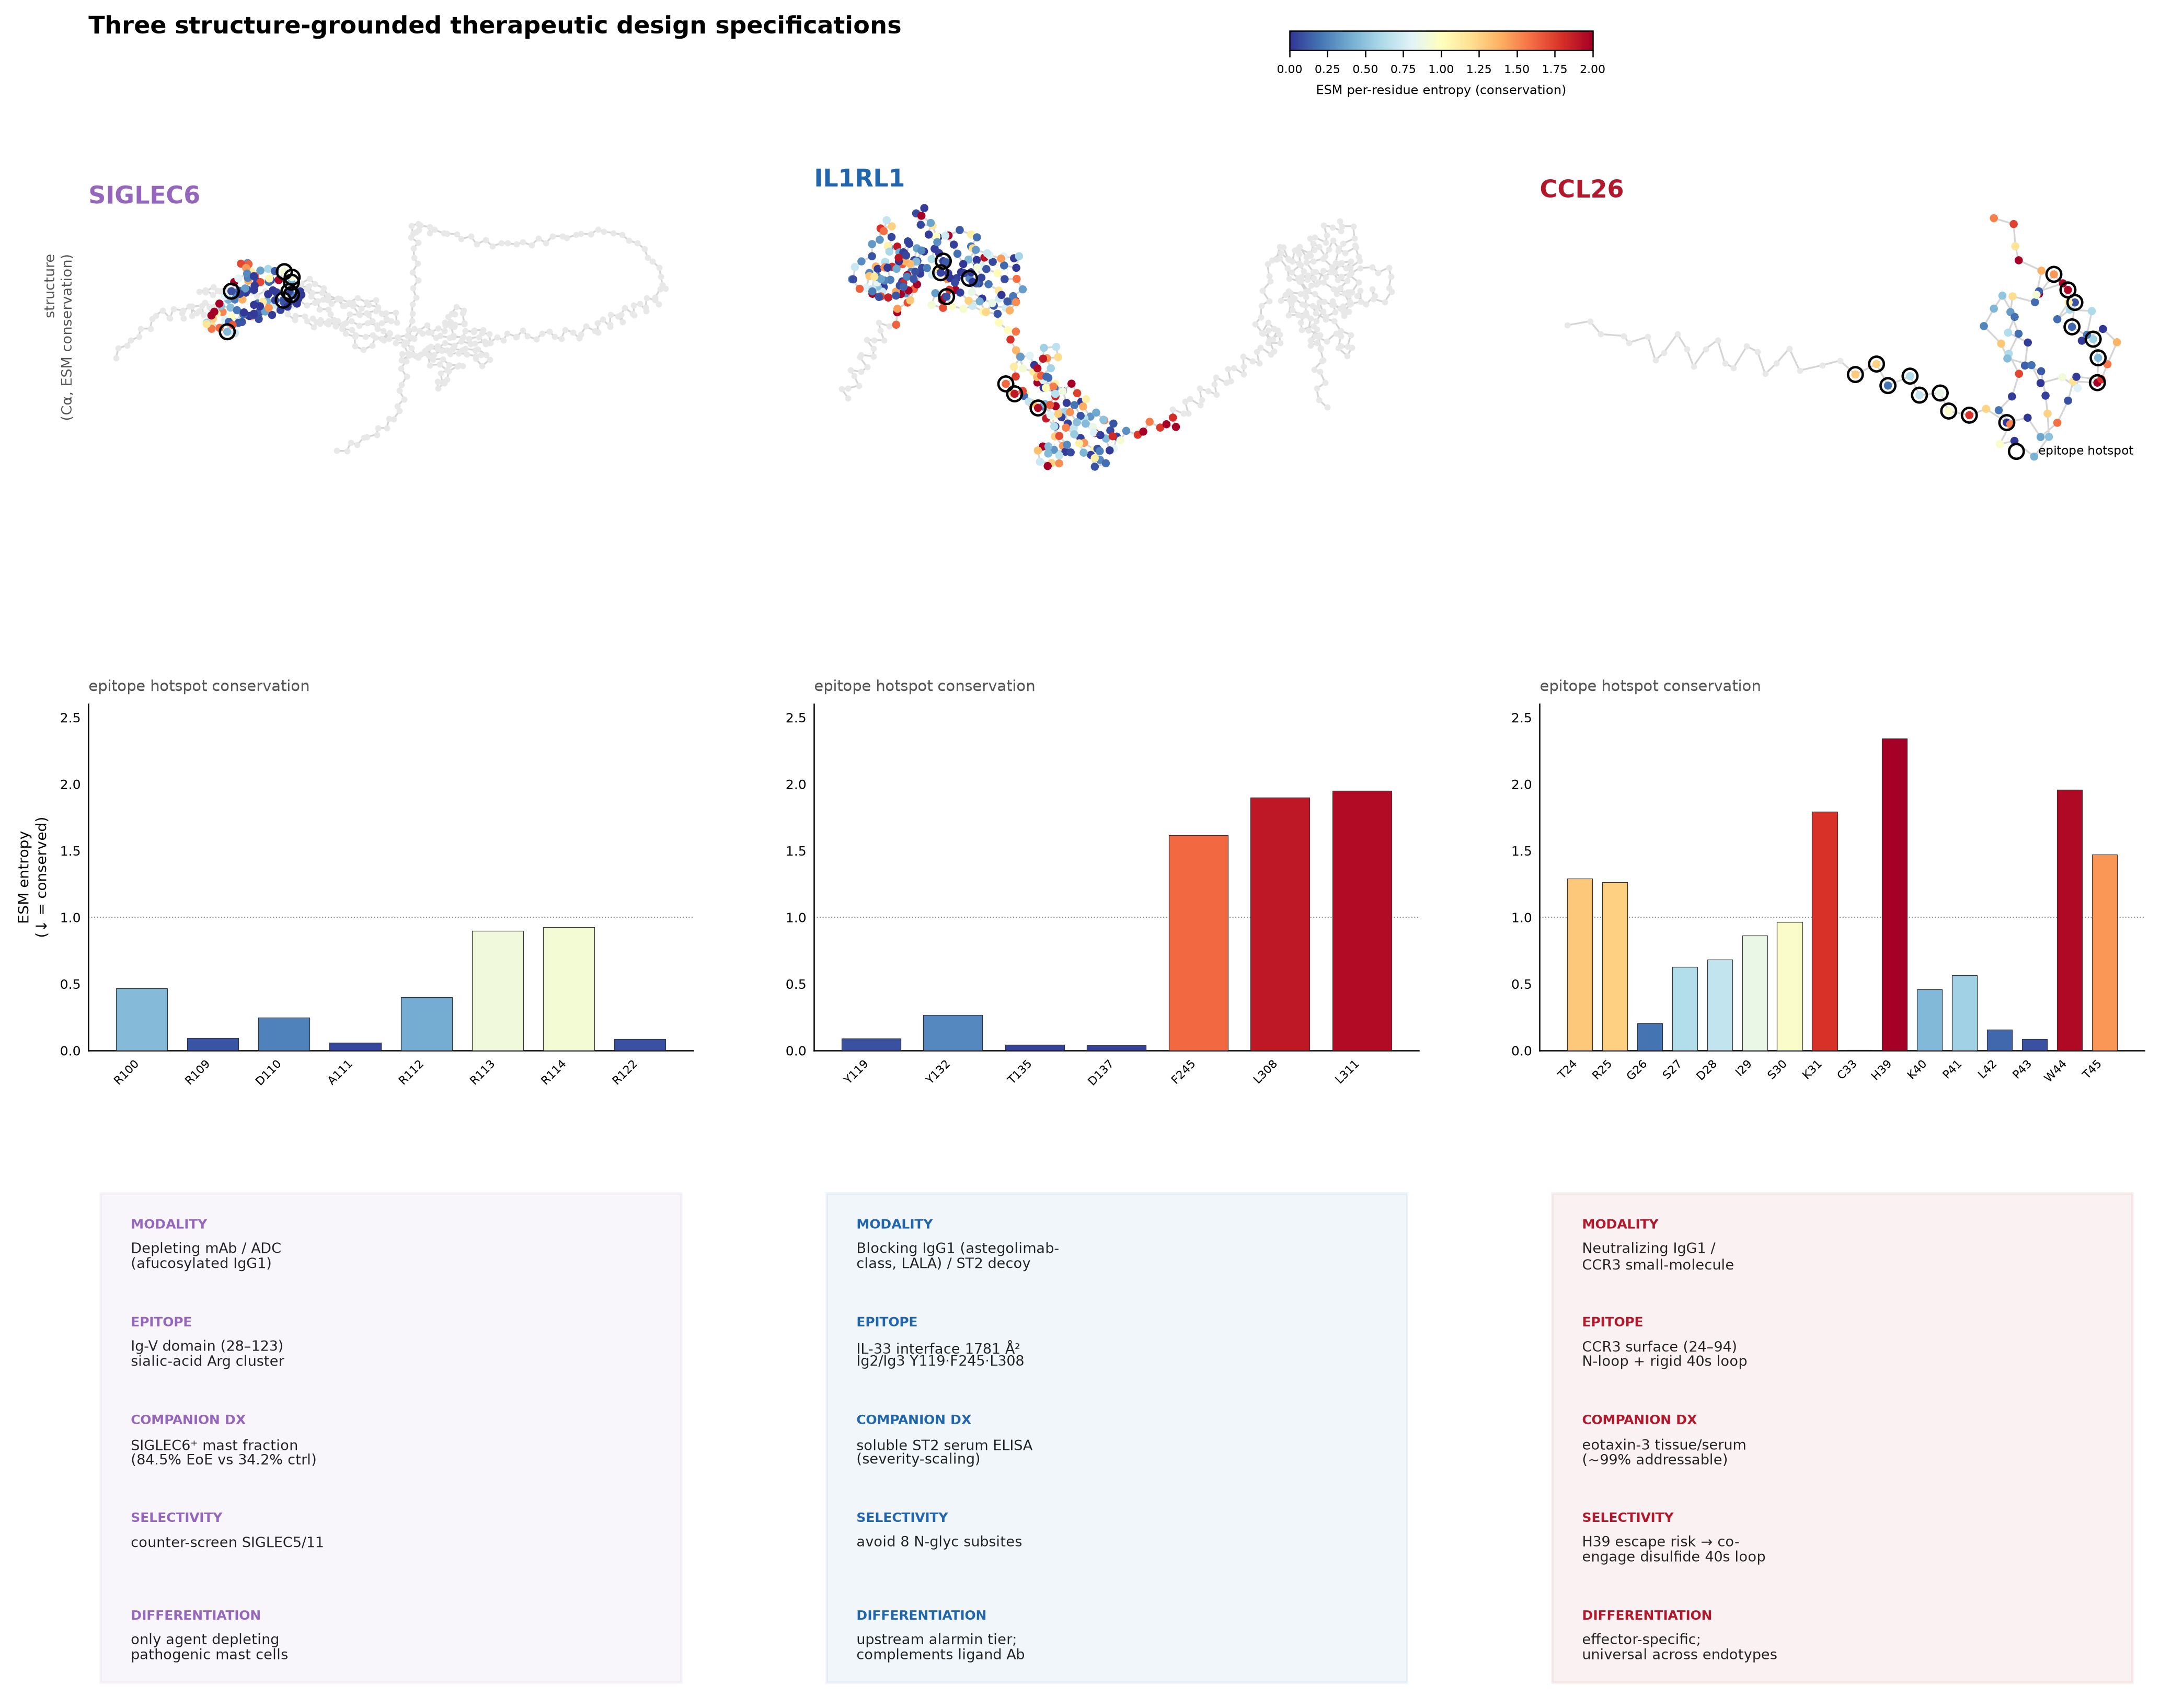
Figure 5. Three therapeutic design specifications. For SIGLEC6, IL1RL1/ST2 and CCL26: the Cα backbone colored by ESM per-residue conservation with epitope hotspots marked (left), the epitope-hotspot conservation profile (center), and the design-spec card (right).

Each lead ships with a paired companion diagnostic
A target is only actionable in EoE if patients can be selected for it. We specified a companion diagnostic for each lead, matched to its biology and matrix (Fig. 6): a tissue SIGLEC6⁺ mast-fraction readout by biopsy IHC/flow (SIGLEC6⁺ on 84.5% of EoE mast cells versus 34.2% in healthy tissue; the pooled cell-level contrast (P = 3×10⁻³¹) is pseudoreplicated — its extreme exponent reflects the number of mast cells, not the number of patients — so we computed the per-patient contrast directly. Aggregating to the sample level (samples with ≥10 mast cells), the SIGLEC6⁺ mast fraction was a median 77.8% in EoE versus 35.7% in healthy tissue (Mann–Whitney P = 0.003, n = 11 EoE and 5 healthy samples; healthy esophagus yields few mast cells, which limits the healthy denominator). The separation therefore holds at the unit of analysis relevant to a diagnostic cutoff, though the small healthy sample warrants prospective confirmation); a serum soluble-ST2 ELISA for IL1RL1 (repurposing an established cardiac-biomarker platform); and eotaxin-3 by tissue mRNA or serum ELISA for CCL26. Each diagnostic addressed at least 92% of severe-endotype patients, and CCL26 and IL1RL1 readouts addressed 100% of the severe endotype (Fig. 6a), enabling both patient selection and pharmacodynamic monitoring. These addressability figures are derivation-cohort estimates — computed on the same cohorts used to derive the signature and endotypes, with no independent held-out validation set — and should be read as upper bounds pending prospective evaluation. We also flag that the three assays are not of equal maturity: the SIGLEC6⁺ mast-fraction and eotaxin-3 readouts are esophagus-specific, whereas soluble ST2 is a systemic analyte with known lack of esophageal specificity and appreciable population-level background variation, so its companion-diagnostic confidence is lower than the tissue-based readouts and it would require esophagus-anchored cutoff calibration.
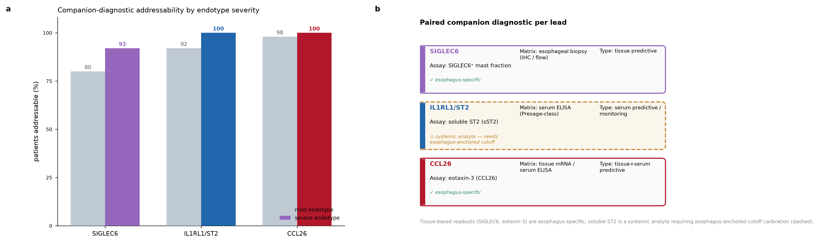
Figure 6. Companion diagnostics. (a) Addressability of the three leads’ diagnostics by endotype severity. (b) Paired assay per lead — analyte, matrix, and diagnostic type.

An antigen-directed arm maps food-allergen epitopes and is calibrated against a real patient
Because the causal antigen in EoE is dietary, we built an antigen-directed arm aimed at the allergen-specific CD4⁺ T cells themselves. We mapped MHC class II binding epitopes across ten food allergens and thirteen HLA-DRB1 alleles (31,512 predictions), quantifying per-allergen epitope burden and per-allele presentation capacity (Fig. 7a,b). To gauge the reliability of the binding predictions, we compared mhcnuggets against IEDB netMHCIIpan-4.1 on the five DRB1 alleles common to both tools (2,424 peptides per allele): per-allele Spearman rank correlation ranged 0.74–0.84 (mean 0.79) and strong-binder agreement (Jaccard) ranged 0.20–0.62 (mean 0.42). The two tools thus agree well on the rank-ordering of peptides but only moderately on the hard strong-binder threshold — appropriate for a prioritization step, and a further reason (below) to treat presentation as a prior rather than a proof. The two soy allergens carried the highest epitope burden, followed by wheat α-gliadin and milk β-lactoglobulin (Fig. 7a).
We then tested the clinical relevance of this map with a blinded, single-patient calibration (Fig. 7c). For an index EoE patient with a full atopic-march history and HLA type DRB1*07:01/DQ2.2 + DRB1*15:01/DQ6.2, we built a personalized epitope panel and ranked candidate trigger foods by presentation — before the patient’s clinically-established food triggers were revealed. Once the milk casein family was represented completely, both true triggers, milk and soy, ranked in the top two of the eight candidate foods, and the five tolerated non-wheat foods ranked low. Both triggers occupying the top two positions has a chance probability of 1/28 (0.036, permutation-confirmed) — a real but modest single-patient signal that we present as hypothesis-generating, not as validation.
Because the two binding predictors agreed only moderately on individual strong-binder calls (Jaccard 0.42), we tested whether this top-two placement was an artefact of the strong-binder threshold. It was not: milk and soy remained the top two foods by epitope burden across strong-binder cutoffs from 250 to 2,000 nM. We note candidly that the per-patient panel driving this ranking was generated by a single predictor (mhcnuggets), not a consensus of both tools, so the ranking should be read as robust to threshold choice but not yet cross-validated against an orthogonal predictor on the patient’s exact alleles — a defined next step. A threshold-free per-peptide binding score reorders the lower ranks (fish rises), underscoring that epitope burden, not mean per-peptide affinity, is the quantity that recovers the true triggers. The single discordance was the most instructive result: wheat, whose gliadin is heavily presented by the patient’s celiac-associated DQ2.2 heterodimer, was clinically tolerated. Two clarifications are warranted. First, celiac disease was clinically excluded in this patient (tissue transglutaminase IgA negative), so the tolerated-wheat observation is not confounded by undiagnosed celiac disease — with the caveat that a single tTG-IgA result does not exclude celiac disease in the setting of selective IgA deficiency, which would require a total-IgA or IgG-based confirmatory test. Second, our epitope predictions were generated on HLA-DRB1 alleles; the DQ2.2-gliadin presentation invoked to explain the wheat discordance is therefore a mechanistic interpretation drawn from the established celiac-disease literature, not an output of our DRB1 pipeline. Extending the prediction to DQ (and DP) loci is a defined next in-silico step; we flag the DRB1-only scope as a limitation of the current map. Antigen presentation, in other words, is a pre-test prior — a necessary but not sufficient condition. A driving food additionally requires an expanded pathogenic-effector-Th2 clone, which is what a functional T-cell assay, not a binding prediction, measures. This principle was reinforced by the first functionally-validated food-specific T-cell receptor in EoE (a β-casein epitope presented on HLA-DRB1*07:01, confirmed by receptor transduction and MHC-II tetramer staining)⁸; notably, once the casein family was complete, our predictor independently recovered the same DR7 β-casein window. Accordingly, the antigen-directed arm treats presentation prediction as a prioritization step and a functional T-cell readout as the specificity-defining measurement.
We note explicitly that trial eligibility for this arm is designed to be HLA-agnostic: because HLA allele frequencies differ across ancestral populations, using predicted epitope burden as an enrollment criterion would systematically under-serve patients whose alleles are common in non-European populations. Predicted burden is retained as a per-patient covariate, never as a gate.
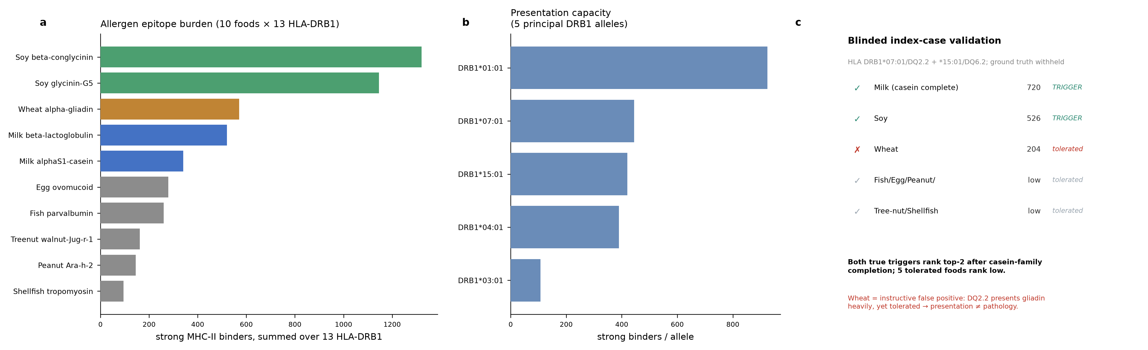
Figure 7. Antigen-directed pMHC arm. (a) Epitope burden across ten food allergens (strong MHC-II binders). (b) Presentation capacity by HLA-DRB1 allele. (c) Blinded index-case validation: both true triggers (milk, soy) rank top-two; tolerated foods rank low; wheat is an instructive false positive (presented but not pathogenic).

A four-phase preclinical roadmap gated on ex-vivo human validation
We sequenced the antigen-directed program into a four-phase preclinical roadmap with explicit go/no-go decision gates (Fig. 8). Phase 1 (ex-vivo human T-cell validation) establishes that dominant food-allergen epitopes drive genuine allergen-specific CD4⁺ responses in EoE patients and that pMHC-II multimer reagents engage and silence those T cells (Gate A: patient-matched multimer stains ≥0.1% of CD4⁺ cells and response tracks individualized epitope burden). Phase 2 builds a scalable multimer reagent and demonstrates efficacy and antigen-specificity in vivo (Gate B: ≥50% reduction in tissue eosinophils versus vehicle, specific to the correct-peptide multimer, with unrelated immunity preserved). Phase 3 generates the GLP toxicology, PK/PD, and GMP CMC package for an IND (Gate C: acceptable safety margin, reproducible GMP lots, clear PK/PD). Phase 4 is a Phase 1b/2a all-comers study in which each patient is treated with their own personalized epitope panel. The ex-vivo T-cell assay is the linchpin: it is the efficacy readout that de-risks every downstream stage. Quoted timelines are illustrative planning estimates for a well-resourced program, not commitments.
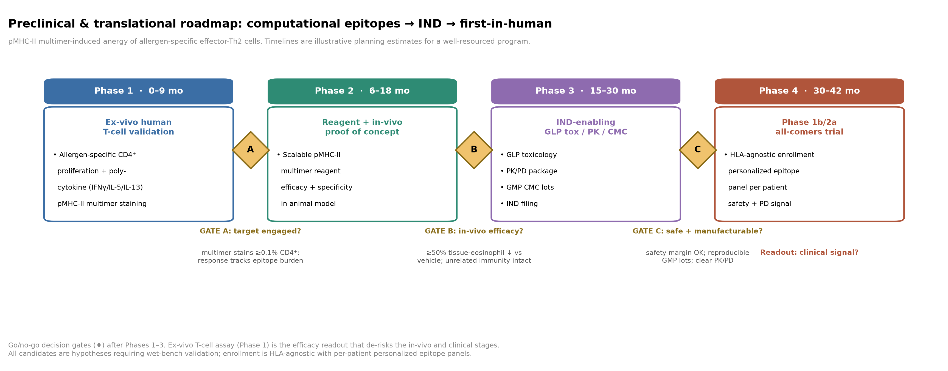
Figure 8. Preclinical & translational roadmap. Four phases from ex-vivo human T-cell validation through in-vivo proof of concept, IND-enabling GLP/CMC, and a Phase 1b/2a all-comers trial, with go/no-go gates A–C. Enrollment is HLA-agnostic with per-patient personalized epitope panels.

Discussion
This pipeline connects, in a single reproducible arc, three activities usually pursued separately: systematic multi-cohort target discovery, structure-grounded therapeutic design with paired diagnostics, and an antigen-directed strategy aimed at the disease’s causal T cells. The biology it recovered is concordant with the EoE literature — the CCL26-dominant signature, the expanded and diversified mast compartment, the epithelial differentiation arrest, and the interferon-and-type-2 inflammatory axis — which both validates the approach and lends credibility to its more novel outputs, chief among them the mast-restricted target SIGLEC6 and the treatment-refractory molecular core (the latter, as noted, resting on a single paired cohort and carried as a hypothesis).
Three features distinguish the program from a conventional target list. First, every lead is paired with a companion diagnostic, so that patient selection and pharmacodynamic monitoring are designed in from the start rather than retrofitted. Second, the antigen-directed arm is anchored to functional ground truth: the blinded index-case calibration, and the concordance with the first functionally-validated EoE food-specific TCR⁸, together establish that presentation prediction prioritizes but does not define a pathogenic antigen. Third, the program’s development plan is gated on a single decisive ex-vivo human assay, which concentrates early risk where it can be resolved cheaply.
The work has clear limitations. It is entirely in silico: every target, epitope, and design specification is a hypothesis awaiting wet-bench validation, and the preclinical roadmap is a plan, not a result. The treatment-refractory core rests on a single paired cohort. The index-case calibration is a single patient and is explicitly hypothesis-generating rather than clinical evidence; it is not, and must not be read as, guidance for any patient’s care. On intellectual property, the antigen-directed concept intersects prior art: the functional identification of EoE food-specific TCRs and associated diagnostic concepts has been disclosed⁸, which bears on freedom-to-operate for the T-cell-assay component and should inform any development decision. These caveats are not incidental — the pipeline is built so that each output is delivered with the evidence and the uncertainty needed to prioritize the next, laboratory, step.
Taken together, the results define a coherent EoE therapeutics program — three antibody/ADC leads with diagnostics, plus an antigen-directed T-cell strategy with a gated development path — derived transparently from public data. We offer it as a scientific foundation on which a focused development effort can be built.

Methods
Data and harmonization. 57 public EoE datasets were inventoried; 9 case-control bulk transcriptomic cohorts (235 samples) were harmonized to a common gene space. Differential expression was pooled across cohorts to a 567-gene high-confidence meta-signature (383 up, 184 down). Single-cell analysis used a published dataset of 166,420 esophageal cells. Endotypes were derived across six cohorts; pseudotime and PPI-refractory analyses as described in the accompanying figures.
Target prioritization and design. Targets were ranked by pooled fold-change, single-cell localization, druggability/accessibility annotation, refractory persistence, and addressable patient fraction. Design specifications used AlphaFold structures (SIGLEC6 O43699, IL1RL1 Q01638, CCL26 Q9Y258) with per-residue ESM conservation and interface/epitope mapping.
Antigen-directed arm. MHC class II binding was predicted across ten food allergens and thirteen HLA-DRB1 alleles (31,512 predictions) with mhcnuggets, cross-validated against IEDB netMHCIIpan-4.1 on the five shared DRB1 alleles (per-allele Spearman 0.74–0.84; strong-binder Jaccard mean 0.42). Predictions were restricted to HLA-DRB1; HLA-DQ and -DP loci were not modelled. Consequently any DQ-restricted interpretation in the index case (e.g. DQ2.2 presentation of gliadin) is drawn from the literature, not from this pipeline, and the index-case food ranking was generated by a single predictor (mhcnuggets) rather than a two-tool consensus. The index-case calibration ranked candidate trigger foods by personalized presentation and was scored against the patient’s blinded, clinically-established food triggers, revealed only after prediction.
Reproducibility. Every figure and table is backed by a lineage-tracked artifact; build code is recoverable from artifact lineage. All analyses were executed under human supervision for biological plausibility, prior art, and ethics.

Data and code availability
All source datasets are public (GEO/SRA/ArrayExpress accessions as listed in the dataset inventory). Derived signatures, design specifications, epitope maps, and figure-build code are available as lineage-tracked project artifacts.

Author contributions and AI use
This campaign was conducted by a human-supervised AI agent. The agent executed data harmonization, statistical analysis, figure generation, and drafting; human supervisors set scientific goals, tested biological plausibility, supplied key prior art, and made all ethical and design judgments. A companion Perspective documents the human–AI operating model and correction ledger in full.

Competing interests
The authors intend to develop an EoE therapeutics program based on the targets, diagnostics, and antigen-directed strategy described here, and therefore hold a financial and intellectual interest in these results. The antigen-directed T-cell-assay concept intersects disclosed third-party prior art⁸, for which freedom-to-operate has not been formally assessed. The work was produced by a proprietary AI research agent under human supervision. Final author-specific competing-interest declarations will be completed to the journal’s policy on submission. [Author-specific entries to be completed.]

Display items
- Figure 1 — End-to-end pipeline overview
- Figure 2 — Discovery meta-signature
- Figure 3 — Single-cell landscape
- Figure 4 — Endotypes, differentiation arrest, GWAS, refractory core
- Figure 5 — Three therapeutic design specifications
- Figure 6 — Companion diagnostics
- Figure 7 — Antigen-directed pMHC arm and blinded index-case validation
- Figure 8 — Preclinical & translational roadmap
- Table 1 — Tier-A target dossier
- Table 2 — Three-lead design specifications

References
- Rothenberg, M. E. Molecular, genetic, and cellular bases for treating eosinophilic esophagitis. Gastroenterology (2015). Foundational EoE pathogenesis (see also refs 2–4).
- Blanchard, C. et al. Eotaxin-3 and a uniquely conserved gene-expression profile in eosinophilic esophagitis. J. Clin. Invest. 116, 536–547 (2006). https://doi.org/10.1172/jci26679
- Furuta, G. T. et al. Eosinophilic esophagitis in children and adults: a systematic review and consensus recommendations. Gastroenterology (2007). https://doi.org/10.1053/j.gastro.2007.08.017
- Rothenberg, M. E. Eosinophilic gastrointestinal disorders (EGID). J. Allergy Clin. Immunol. (2004). https://doi.org/10.1016/j.jaci.2003.10.047
- Dellon, E. S. et al. Dupilumab in adults and adolescents with eosinophilic esophagitis. N. Engl. J. Med. (2022). https://doi.org/10.1056/NEJMoa2205982
- Ben-Baruch Morgenstern, N. et al. Single-cell RNA sequencing of the esophageal epithelium in eosinophilic esophagitis. J. Allergy Clin. Immunol. 149, 2062–2077 (2022). https://doi.org/10.1016/j.jaci.2022.02.025
- Jacobse, J. et al. The mast cell function in eosinophilic esophagitis. J. Allergy Clin. Immunol. (2024). https://doi.org/10.1016/j.jaci.2023.10.002
- Dilollo, J. et al. A molecular basis for milk allergen immune recognition in eosinophilic esophagitis. J. Allergy Clin. Immunol. (2025). https://doi.org/10.1016/j.jaci.2025.01.008
All references were retrieved during the campaign’s literature mining and verified against CrossRef.

