EoE omics campaign — three therapeutic candidates

A public-data omics campaign nominates and structurally specifies three therapeutic candidates for the refractory eosinophilic-esophagitis population
Authors: [Author list] Affiliations: [Affiliations] Correspondence: [Corresponding author]

Abstract
Eosinophilic esophagitis (EoE) is a chronic, type-2 inflammatory disease of the esophagus whose only approved biologic, dupilumab, leaves a substantial fraction of patients incompletely controlled. We asked whether an integrative re-analysis of public EoE omics data could nominate mechanistically distinct, structurally tractable therapeutic candidates positioned for the refractory population. From an inventory of 57 public datasets we harmonized nine case-control bulk transcriptomic cohorts (235 samples: 152 EoE, 83 control) into a 567-gene meta-signature (383 up, 184 down) that recovered every canonical EoE marker with the correct direction — led by the eosinophil chemoattractant CCL26/eotaxin-3 (pooled log₂FC 4.56, significant in all nine cohorts) — over a dominant interferon, cytokine-signaling and NF-κB program superimposed on loss of epithelial barrier and keratinization. Single-cell analysis of 166,420 esophageal cells confirmed a 14-fold mast-cell expansion (2.63% vs 0.19% of cells; Mann–Whitney P = 7.2×10⁻⁵) and basal-epithelial depletion. Validation placed the barrier defect in a developmental frame — EoE epithelium is arrested short of terminal differentiation — resolved the interferon signal as a T-cell-sourced type-II/IFN-γ axis, reproduced a mild-to-severe endotype gradient across all six cohorts tested, and, using recovered proton-pump-inhibitor (PPI) response labels, localized the lead targets to the refractory (non-responder) population. Druggability annotation returned a shortlist dominated by secreted and surface-accessible proteins (91 of 120 up-regulated druggable genes, 76%). Three leads were carried into structure-grounded design specifications: SIGLEC6, a mast-restricted receptor, for a depleting antibody or antibody–drug conjugate; IL1RL1/ST2, the IL-33 alarmin receptor, for a blocking antibody mapped to an experimental IL-33/ST2 interface; and CCL26, for neutralization or CCR3 antagonism. Each specification integrates epitope-conservation analysis, developability screening and a paired companion-diagnostic assay. The campaign was conducted entirely on public data and in silico; every candidate is a hypothesis for experimental validation.

Introduction
Eosinophilic esophagitis is a chronic, immune-mediated disease in which type-2 inflammation drives esophageal eosinophilia, tissue remodeling and, over time, fibrostenotic complications.3,12 Diagnosis rests on symptomatic esophageal dysfunction together with a mucosal eosinophil count exceeding a histologic threshold, and the disease is now recognized as a leading cause of dysphagia and food impaction in adolescents and adults.12 Its molecular hallmark — a conserved esophageal transcriptome dominated by the eosinophil chemoattractant eotaxin-3 (CCL26) — has been defined for nearly two decades.2
The therapeutic landscape has, until recently, relied on dietary elimination, topical corticosteroids and PPIs. Dupilumab, which blocks IL-4/IL-13 signaling, is the first biologic approved for EoE and establishes proof of concept for cytokine-directed therapy.1 Yet a meaningful fraction of patients do not reach histologic remission, and dupilumab’s broad Th2 blockade neither depletes the expanded mast-cell compartment nor directly addresses the remodeling that produces strictures. There is a clear need for agents with orthogonal mechanisms, ideally selected for the patients least served by current options.
Public omics data for EoE are now abundant but fragmented across dozens of studies, platforms and tissue contexts. We reasoned that harmonizing these data into a single, direction-consistent meta-signature — then layering single-cell resolution, developmental trajectory, endotype structure, human genetics and drug-response information onto it — could nominate targets that are simultaneously disease-central, mechanistically distinct from the approved agent, and biologically accessible to a protein therapeutic. Here we report that campaign and its three lead design specifications. All analyses use publicly available data; the work is computational, and each nomination is a prioritized hypothesis rather than a validated drug target.

Results

Discovery: a direction-consistent meta-signature over an interferon-dominated inflammatory program
We assembled an inventory of 57 public EoE datasets and harmonized nine case-control bulk transcriptomic cohorts — 235 samples in total (152 EoE, 83 control) — into a common gene space. Random-effects meta-analysis across cohorts yielded a high-confidence signature of 567 genes (383 up-regulated, 184 down-regulated in EoE; Fig. 1a). The signature recovered every canonical EoE marker with the expected direction: CCL26/eotaxin-3, the most disease-specific transcript,2 was the standout up-regulated gene (pooled log₂FC 4.56, up in all nine cohorts), alongside POSTN, CDH26, ALOX15 and the mast-cell markers TPSAB1 and CPA3, while the barrier and keratinization genes DSG1, FLG, SPINK7 and KRT4 were coordinately down-regulated.
Pathway enrichment resolved the up-regulated program into a dominant interferon and cytokine-signaling axis — interferon-γ response, interferon-α response and broad cytokine signaling were the most significant terms — while the down-regulated program was almost entirely epithelial: keratinization, keratinocyte differentiation, epidermis development and cornified-envelope formation (Fig. 1b). This is the transcriptional signature of an inflamed epithelium losing its differentiated barrier, consistent with the established pathophysiology of the disease.3,8
Because a therapeutic program requires accessible targets, we annotated the druggability of the signature. Among 120 up-regulated genes with a tractable target class, 91 (76%) were secreted or cell-surface proteins (Fig. 1c) — a shortlist enriched for exactly the biology a protein therapeutic can reach.
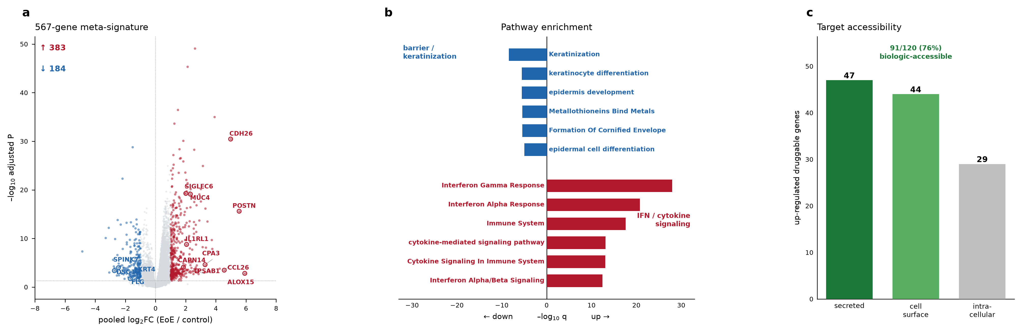 Figure 1. Discovery meta-signature. (a) Volcano plot of the 567-gene high-confidence meta-signature across nine harmonized cohorts; canonical EoE markers are labeled and colored by direction. (b) Diverging pathway enrichment: up-regulated genes (red) are dominated by interferon/cytokine signaling; down-regulated genes (blue) by barrier and keratinization programs. (c) Target accessibility among up-regulated druggable genes — 91 of 120 (76%) are secreted or surface-accessible.

A single-cell landscape confirms mast-cell expansion and epithelial depletion
To resolve the cellular source of the signature, we analyzed a published single-cell dataset of 166,420 esophageal cells (73,175 EoE, 93,245 healthy; Fig. 2a). The most striking compositional change was a 14-fold expansion of the mast-cell compartment, from a mean 0.19% of cells in healthy tissue to 2.63% in EoE (Mann–Whitney P = 7.2×10⁻⁵; Fig. 2b,d), accompanied by a relative depletion of basal epithelium (42.7% → 30.6%). This expansion was not merely numerical: in healthy tissue mast cells occupied essentially a single quiescent transcriptional state, whereas in EoE they diversified into several activated states (Fig. 2c), consistent with recent single-cell characterization of a disease-associated EoE mast compartment.5,6
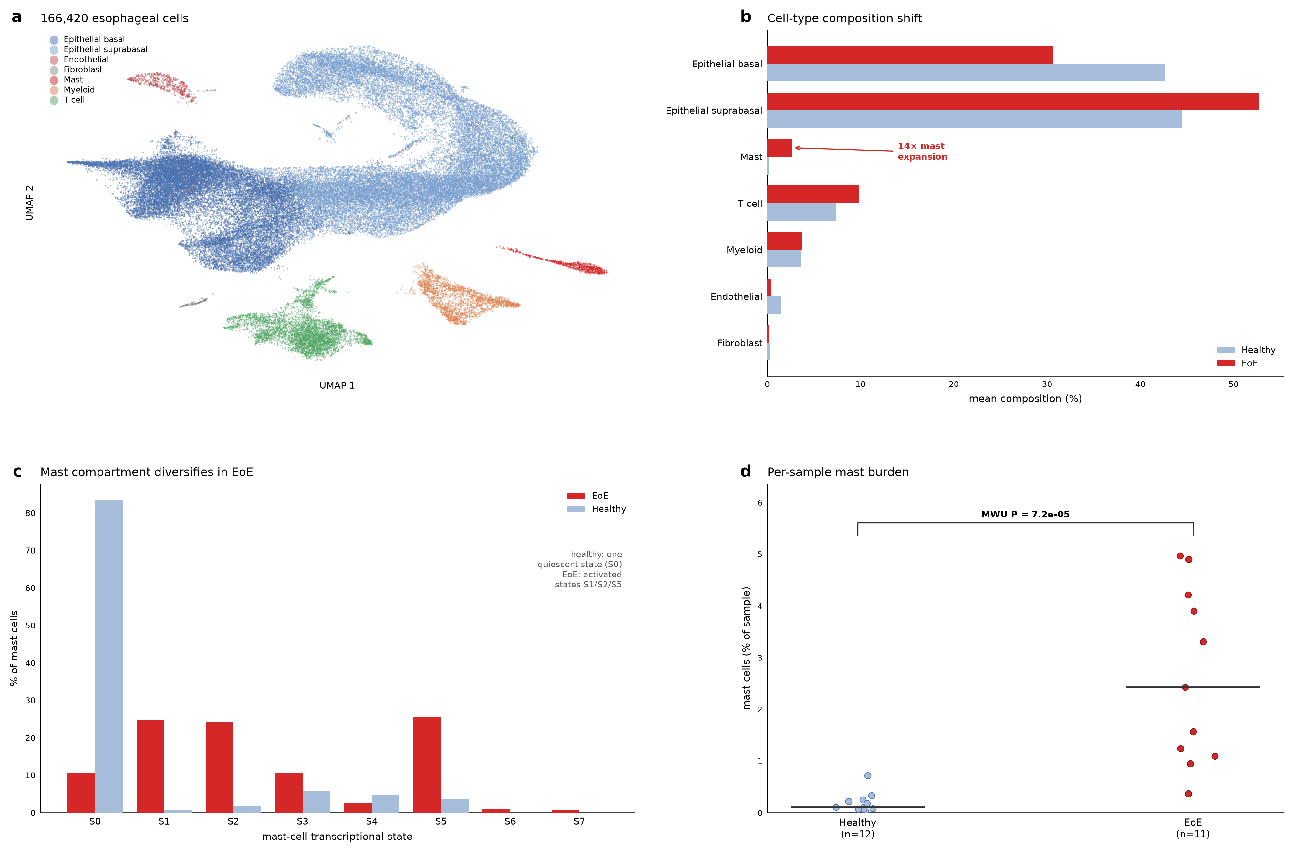 Figure 2. Single-cell landscape. (a) UMAP of 166,420 esophageal cells colored by cell type. (b) Mean cell-type composition, EoE versus healthy, showing the 14-fold mast expansion and basal-epithelial depletion. (c) Mast-cell transcriptional states: a single quiescent state in health diversifies into activated states in EoE. (d) Per-sample mast-cell burden (Mann–Whitney P = 7.2×10⁻⁵).

Validation: differentiation arrest, a type-II axis, reproducible endotypes and a refractory locus
Four orthogonal analyses tested and contextualized the discovery signature (Fig. 3). First, diffusion-pseudotime analysis of the epithelial compartment placed the barrier defect in a developmental frame: healthy epithelium progresses to a terminal-differentiation peak that is largely absent in EoE, where cells accumulate at earlier pseudotime (Fig. 3a). A marker-based terminal-differentiation index gave 5.4% of EoE epithelial cells versus 17.9% in health — an arrest short of terminal keratinocyte identity rather than a wholesale loss of epithelium.8
Second, module scoring resolved the interferon dominance seen in Figure 1 into a type-II/IFN-γ axis: the IFN signal tracked with T-cell content and the epithelium behaved as responder rather than source, matching the established view of EoE as a T-cell-driven type-2/type-II disease.3 Third, unsupervised stratification recovered a reproducible mild-to-severe inflammatory gradient — three endotypes ordered by a composite inflammation score — that was present in all six cohorts tested (Fig. 3b), consistent with previously described EoE molecular endotypes.7 Seven signature genes carried EoE genetic risk from prior GWAS, with the strongest odds ratios at susceptibility loci such as CAPN14 (OR 1.77) and DSG1 (OR 2.22; Fig. 3c), locating part of the signature in inherited disease risk rather than reactive inflammation alone.8
Fourth, and most consequential for therapeutic positioning, we recovered PPI-response labels and asked how the lead targets behaved across treatment. All ten Tier-A targets normalized toward baseline in PPI responders but persisted in non-responders (Fig. 3d) — placing them squarely in the refractory population that most needs a mechanistically novel agent.
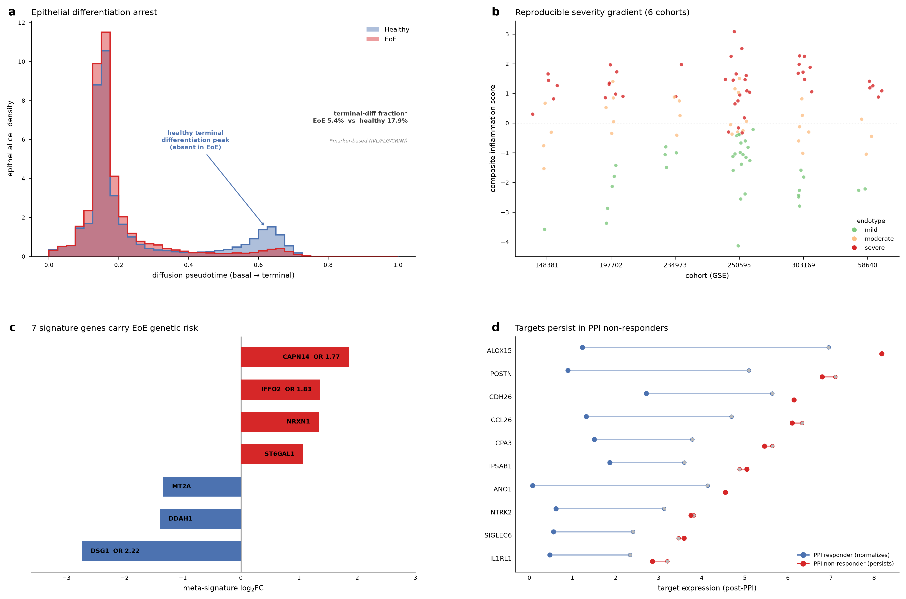 Figure 3. Validation. (a) Epithelial diffusion pseudotime: EoE lacks the healthy terminal-differentiation peak (terminal-diff fraction 5.4% vs 17.9%). (b) A reproducible three-endotype severity gradient across all six cohorts tested. (c) Seven signature genes carry EoE GWAS risk, shown with meta-signature effect size and odds ratios. (d) PPI-response triage: lead targets normalize in responders (blue) but persist in non-responders (red).

Target prioritization identifies three mechanistically distinct leads
Integrating effect size, cell-type specificity, endotype addressability, PPI-refractory persistence and druggability produced a prioritized landscape (Fig. 4, Table 1). The Tier-A shortlist is uniformly secreted or surface-accessible, refractory-persistent, and addresses a near-universal fraction of patients across endotypes. From it we selected three leads spanning distinct mechanistic nodes and therapeutic modalities so that they are complementary rather than redundant with dupilumab:
- CCL26 (eotaxin-3) — the effector eosinophil-recruitment node; highest patient addressability and priority score; a neutralizing antibody or CCR3 antagonist provides eosinophil-specific blockade downstream of, and narrower than, broad Th2 suppression.
- SIGLEC6 — a mast-restricted surface receptor and the most homogeneous target in the shortlist (I² = 37); a depleting antibody or ADC removes the pathogenic mast population that dupilumab does not touch.
- IL1RL1/ST2 — the IL-33 alarmin receptor; upstream of the IL-4/IL-13 axis, so receptor-side blockade hits the initiating epithelial-alarmin signal and scales with severity.10
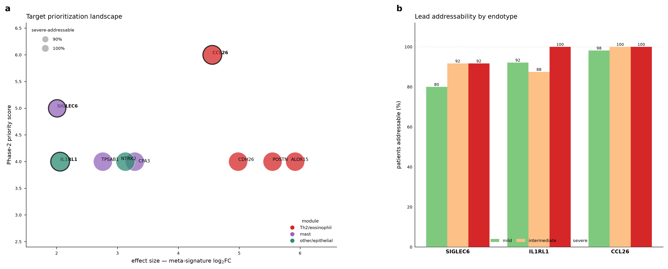 Figure 4. Target prioritization landscape. (a) Tier-A targets positioned by effect size and Phase-2 priority score, sized by severe-endotype addressability and colored by mechanistic module; the three leads are outlined. (b) Addressability of the three leads across mild, intermediate and severe endotypes.
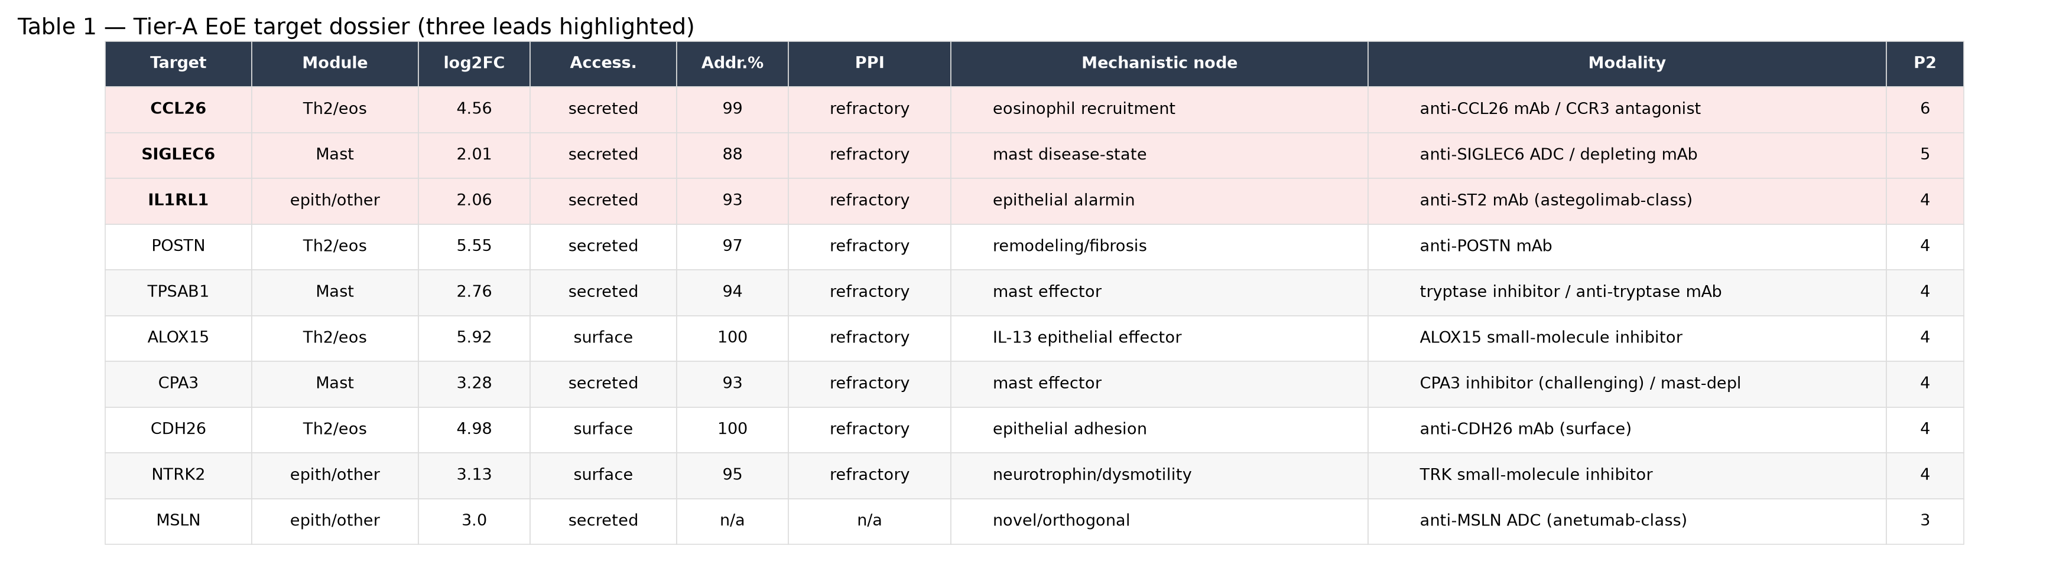 Table 1. Tier-A EoE target dossier. Effect size, accessibility, mean addressability, PPI class, mechanistic node, proposed modality and Phase-2 priority score for the ten Tier-A targets; the three leads are highlighted.

Structure-grounded design specifications for the three leads
For each lead we produced a design specification anchored to a three-dimensional structure and a per-residue conservation analysis from an ESM protein language model (Fig. 5, Table 2).
SIGLEC6 was specified as a depleting monoclonal antibody or ADC on an afucosylated human IgG1 backbone (enhanced ADCC; internalizing receptor supports an ADC payload). The proposed epitope lies in the Ig-V domain (residues 28–123): either the sialic-acid-binding arginine cluster (R100, R109–114, R122), which blocks ligand engagement and enables depletion, or a non-competitive acidic face for pure depletion. Because the arginine cluster is conserved across the Siglec family, selectivity must come from the surrounding loops, and counter-screening against SIGLEC5/SIGLEC11 and against placental trophoblast SIGLEC6 is mandatory. The companion diagnostic is the SIGLEC6⁺ mast-cell fraction, which is markedly enriched in EoE (84.5% of EoE mast cells versus 34.2% in healthy tissue, P = 3×10⁻³¹).6
IL1RL1/ST2 was specified as an effector-silent (LALA) blocking IgG1 in the astegolimab class,11 or an engineered soluble ST2 decoy, targeting the IL-33 binding interface. That interface — 1,781 Å² across the Ig1–Ig2–Ig3 domains, mapped from the experimental IL-33/ST2 complex — presents a contiguous high-buried-area patch on Ig2/Ig3 with aromatic hotspots (Tyr119, Phe245, Leu308) that are well conserved in the language model, flanked by N-glycosylated sub-regions the paratope must avoid. Receptor-side blockade is isoform- and oxidation-independent and therefore complements ligand-directed anti-IL-33 antibodies. The companion diagnostic is serum soluble ST2, shed from the same gene and already an established clinical assay.10
CCL26 was specified as a high-affinity neutralizing IgG1 occluding the CCR3-engagement surface (the N-terminal site-2 and the disulfide-rigid N-loop/40s-loop docking surface), with a CCR3 small-molecule antagonist as a parallel route that additionally captures the related eotaxins CCL11/CCL24. The conservation analysis flagged a specific liability: the single escape-risk position in the epitope, His39 (ESM entropy 2.34), falls within the N-loop docking surface, so the specification steers the paratope toward the invariant disulfide-constrained 40s loop or favors the CCR3-antagonist route. The companion diagnostic is tissue or serum eotaxin-3, a canonical EoE marker that is positive in nearly all patients.2
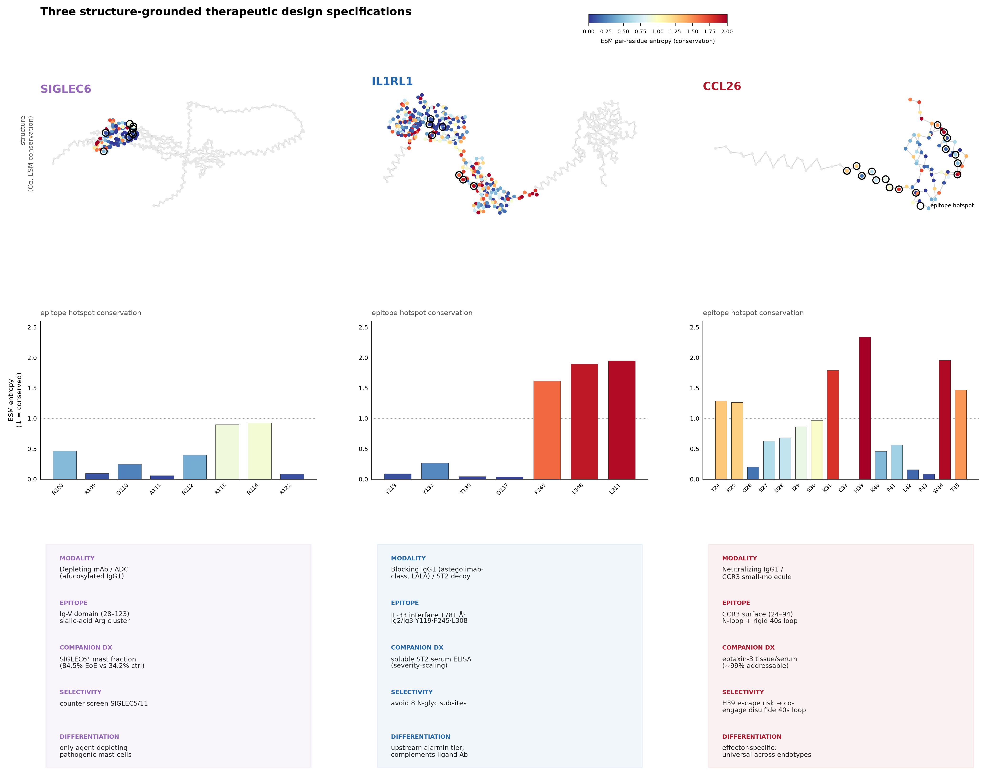 Figure 5. Three therapeutic design specifications. Columns: SIGLEC6, IL1RL1/ST2, CCL26. Top: Cα backbone (2D projection) colored by ESM per-residue conservation entropy, with proposed epitope hotspots ringed. Middle: conservation profile of the epitope hotspot residues (lower entropy = more conserved; CCL26 His39 stands out as the escape-risk position). Bottom: design-specification card (modality, epitope, companion diagnostic, selectivity, differentiation from dupilumab).
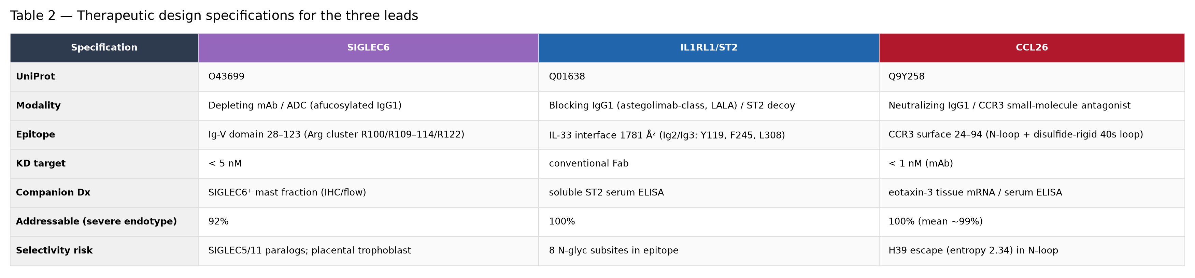 Table 2. Therapeutic design specifications for the three leads. Modality, epitope, affinity target, companion diagnostic, severe-endotype addressability and principal selectivity risk for SIGLEC6, IL1RL1/ST2 and CCL26.

Discussion
Re-analysis of public EoE omics data, integrated across bulk transcriptomics, single-cell resolution, developmental trajectory, endotype structure, human genetics and drug-response information, converged on three therapeutic candidates that are individually disease-central and collectively orthogonal to the one approved biologic. CCL26 blockade acts at the eosinophil-recruitment effector node; SIGLEC6 depletion removes the expanded mast population; IL1RL1/ST2 blockade acts upstream at the alarmin tier. None of these mechanisms is addressed directly by IL-4/IL-13 blockade, and all three targets persist specifically in PPI non-responders — the population for whom a new agent is most valuable.
Two features distinguish this shortlist from a conventional differential-expression list. First, the targets were filtered for biological accessibility and refractory persistence, not effect size alone, so the ranking reflects therapeutic positioning rather than statistical prominence. Second, each lead carries a structure-grounded design specification with an explicit epitope, a conservation-informed liability analysis and a paired companion diagnostic — the elements needed to move from a target name to a testable molecule. The SIGLEC6 mast-state association, in particular, is a recently reported observation6 that our analysis reproduced and extended, and it exemplifies the kind of mechanistically specific target that single-cell resolution makes visible.
The limitations are those of any in silico campaign. All data are public and retrospective; the meta-signature, while direction-consistent, aggregates heterogeneous platforms and shows substantial between-cohort heterogeneity for some genes. The PPI-refractory analysis rested on the available paired cohort and should be treated as a single-cohort observation pending replication. The design specifications are hypotheses: epitopes are proposed from structure and conservation, not from experimental binding; no antibody has been made, and no candidate has been tested in vitro or in vivo. The CCL26 structure is an AlphaFold model rather than an experimental one. Each nomination therefore defines an experiment — antibody generation and affinity measurement, selectivity counter-screens, and functional assays in primary EoE tissue — rather than a validated drug.
Within those bounds, the campaign shows that integrative re-analysis of existing public data can nominate mechanistically distinct, structurally specified, patient-stratified therapeutic candidates for the refractory EoE population, and can hand each one to the bench as a concrete, prioritized hypothesis.

Methods
Dataset inventory and harmonization. Public EoE datasets were inventoried from GEO and related repositories (57 datasets). Nine case-control bulk transcriptomic cohorts (235 samples: 152 EoE, 83 control) with recoverable case/control labels and compatible platforms were harmonized to a common gene space.
Meta-signature. Per-cohort differential expression was combined by random-effects meta-analysis (pooled log₂ fold-change, standard error, z-statistic, Benjamini–Hochberg-adjusted P, and between-cohort heterogeneity I²). The high-confidence signature comprised 567 genes passing significance and cross-cohort reproducibility criteria (383 up, 184 down). Pathway enrichment used MSigDB Hallmark, Reactome and GO Biological Process gene sets.
Single-cell analysis. A published esophageal single-cell dataset (166,420 cells) was used with author cell-type labels. Composition was computed per sample; disease comparison of mast-cell fraction used the Mann–Whitney U test. Mast-cell transcriptional states were taken from sub-clustering of the mast compartment.
Trajectory and endotypes. Epithelial diffusion pseudotime was computed on the epithelial compartment; a marker-based terminal-differentiation index (IVL/FLG/CRNN) quantified the differentiated fraction. Patient endotypes were derived by unsupervised clustering on module scores (Th2/eosinophil, mast, IFN, barrier) and ordered by a composite inflammation score; reproducibility was assessed across six cohorts. GWAS overlap used published EoE risk loci.
Druggability and prioritization. Targets were annotated for secreted/surface accessibility, target class, antibody/small-molecule tractability, existing drugs, PPI-response behavior, endotype addressability and a composite priority score. The Tier-A shortlist and three leads were selected to span distinct mechanistic modules and modalities.
Structure and conservation. Structures were AlphaFold models (SIGLEC6, UniProt O43699; IL1RL1, Q01638; CCL26, Q9Y258, AlphaFold DB v6) and the experimental IL-33/ST2 complex (PDB 4KC3). Interface residues were defined by relative solvent accessibility or buried surface area. Per-residue conservation was scored with an ESM protein language model (wild-type log-likelihood and entropy); epitope hotspots were taken from interface analysis and the language-model conservation profile.
Software and reproducibility. All analysis was performed in Python (numpy, pandas, scipy, matplotlib). All input datasets are public; derived tables and figures are provided as artifacts.

Data and code availability
All primary datasets are publicly available from GEO and associated repositories (inventory of 57 datasets; nine harmonized bulk cohorts; single-cell dataset as cited). Derived meta-signature tables, target dossiers, design specifications, and all figure-source data are available as project artifacts. Structures are from the AlphaFold Protein Structure Database (O43699, Q01638, Q9Y258) and the PDB (4KC3).

Author contributions
[To be completed.] This analysis was performed with a domain-supervised AI research agent operating on public data under human direction; all target nominations and design specifications were reviewed by the authors.

Competing interests
[To be completed.]

References
- Dellon ES, et al. Dupilumab in adults and adolescents with eosinophilic esophagitis. N Engl J Med 2022. doi:10.1056/NEJMoa2205982
- Blanchard C, et al. Eotaxin-3 and a uniquely conserved gene-expression profile in eosinophilic esophagitis. J Clin Invest 2006. doi:10.1172/JCI26679
- Rothenberg ME. Pathogenesis of eosinophilic esophagitis. J Allergy Clin Immunol 2004. doi:10.1016/j.jaci.2003.10.047
- Furuta GT, et al. Eosinophilic esophagitis in children and adults: consensus recommendations. Gastroenterology 2007. doi:10.1053/j.gastro.2007.08.017
- Ben-Baruch Morgenstern N, et al. Single-cell RNA sequencing of mast cells in eosinophilic esophagitis. J Allergy Clin Immunol 2022. doi:10.1016/j.jaci.2022.02.025
- Jacobse J, et al. SIGLEC6 marks a disease-associated mast-cell population in eosinophilic esophagitis. J Allergy Clin Immunol 2024. doi:10.1016/j.jaci.2023.10.002
- Ruffner MA, et al. Molecular endotyping of eosinophilic esophagitis. Ann Allergy Asthma Immunol 2020. doi:10.1016/j.anai.2019.12.011
- O’Shea KM, et al. Pathophysiology of eosinophilic esophagitis. Gastroenterology 2018. doi:10.1053/j.gastro.2017.06.065
- Politi E, et al. Filaggrin and markers of epithelial barrier in eosinophilic esophagitis. J Pediatr Gastroenterol Nutr 2017. doi:10.1097/MPG.0000000000001419
- Venturelli N, et al. Allergic skin sensitization promotes eosinophilic esophagitis through the IL-33–ST2 axis. J Allergy Clin Immunol 2016. doi:10.1016/j.jaci.2016.02.034
- Kelsen SG, et al. Astegolimab (anti-ST2) efficacy and safety in adults with severe asthma. J Allergy Clin Immunol 2021. doi:10.1016/j.jaci.2021.03.044
- Muir A, Falk GW. Eosinophilic esophagitis: a review. JAMA 2021. doi:10.1001/jama.2021.14920

